Activity Sheets

Part 4

Activity Sheet #4-1

Scoring for “How Well Do You Lead Through Change?”
0 – 40 Not ready/confident to lead change
41 - 65 Need skill building to lead change
66 - 90 Need strong support to lead change
91 - 115 Willing to lead change with a mentor
116 – 140 Ready to lead the change charge!

Stages of Change

1. Unaware/Denial

Characteristics:

Strategies:

2. Acceptance

Characteristics:

Strategies:

3. Commitment

Characteristics:

Strategies:

4. Action

Characteristics:

Strategies:

5. Maintenance

Characteristics:

Strategies:

ACTIVITY SHEET #4-2 CASE STUDY

As John, the CEO of a 25-year-old non-profit organization, walked into the staff lounge he was met with chaos. An announcement had just been made about the generous donation from a benefactor to get computers for every employee and a customer relations management (CRM) system for the organization.

Mike was telling everyone about how great it would be for each person to have computers and access to the CRM. Joan was comforting Marie, who was crying because she didn’t even know how to turn on a computer. Joan was telling Marie that she wasn’t sure that everyone having a computer was necessary. Sue was talking excitedly about the CRM she had used in another company for tracking information. She felt this was going to revolutionize the entire organization and positively impact the work they do for children. She was going to make an appointment with John immediately to get things moving. Mike argued that tracking information at this organization would be different than it was at Sue’s former organization. She didn’t know enough about what they needed to keep track of to create the right system. Mike wanted more information about what could be done, how much time it would take, how accessible it would be, and what kind of information they could gather. He wasn’t sure he wanted to use a system that might or might not work for them.

John shook his head. How was he going to manage this change? Was he going to be able to get everyone on board and moving in the same direction?

For each of these people, answer the following questions: What is this person’s level of energy in this moment? What stage of change is this person in? What basic human need(s) are involved for this person? What support does this person need in this stage of change?

Person | Level of Energy | Stage of Change | Basic Human Need(s) | Support Needed
John

Mike

Marie

Joan

Sue

Activity Sheet #4-3

Additional Strategies:

Dealing with Resistance and Fear

- Hear them out

- Allow time for the idea of change to sink in

- Be in constant communication

- Encourage discussion to problem-solve

Consideration, Discovery and Openness
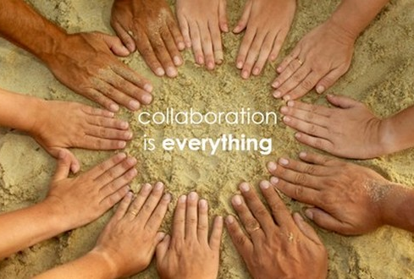
- Provide direction

- Encourage creativity

- Inspire collaboration and teamwork

